Programming learning journal (with screenshots of some of my game based on the component coursework, a rhythm game)

25/09/2018

Wrote name on a lolly stick to be randomly selected in the future to answer questions on programming.

Paul talked about the traffic light cup system he has, red for can’t progress without help, yellow for can do some other things and progress, green for no problems.

02/10/2018

Made a small model from Lego blocks without showing anyone.

Took a few pictures of the model from different angles and then took apart the Lego model.

Wrote down a list of instructions to build the model again, but then moved to a different seat to try some other peoples Lego instructions whilst other people tried to read and do my instructions.

09/10/2018

Started experimenting with behaviour scripts for eventual submission onto Moodle. Paul showed a guard script which demonstrated moving a cube into line of sight and the cube changing colour as a result.

26/10/2018

Created the first programming behaviour tutorial which instructed how to spawn a cube every time q is pressed (including the script and how to attach it).

02/11/2018

Created the second programming behaviour tutorial which instructed how to change the colour of dropped cubes every time the scene is run (including the script and how to attach it).

08/11/2018

Created the third programming behaviour tutorial which instructed how to move a collider in front of a non-moving collider. Which also included a lock input variable in the script to prevent the user moving the collider too fast and breaking the position of the moving collider (including the script and how to attach it).

15/11/2018

Created the second programming behaviour tutorial which instructed how to destroy a dropped cube and add to a score displayed in the scene every time the scene is run (including the script and how to attach it).

20/11/2018

Paul and I were working on figuring out why my game combos only played once and after stopping didn’t play again, after many lines of debugging we found that I didn’t set the combos to “n” (n for not running) after the FountainsLeft.Stop; & FountainsRight.stop; We fixed this by adding in fountainSpawnLeft = “n”; & fountainSpawnRight = “n”;

I fixed my hold down notes not properly adding to the score by adding an extra void and inputting values for each of the four success colliders that correspond to each of the four sides of the screen where blocks are spawned:

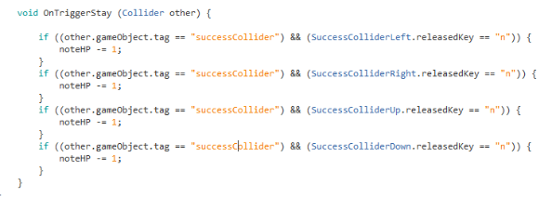

27/11/2018

Paul and I were working on why my health bar didn’t work. I created a health bar manager to work with my health bar script and Paul helped link the health bar with my Game master script (which automatically spawned in cubes based on values I set).

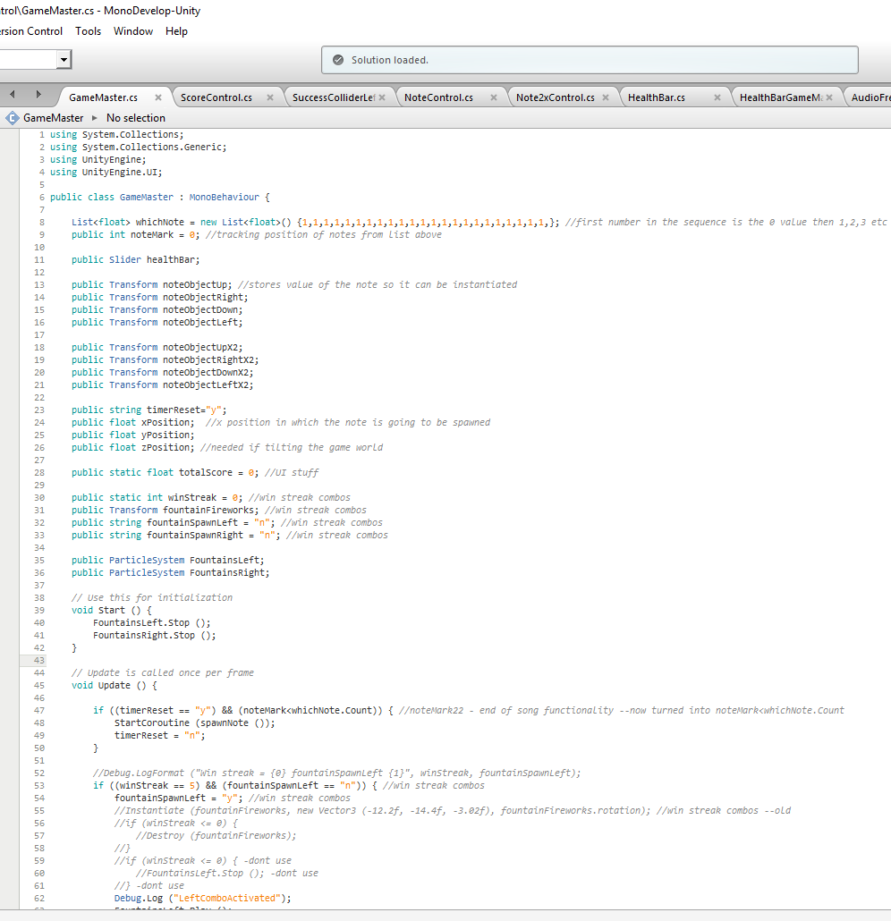Game master:

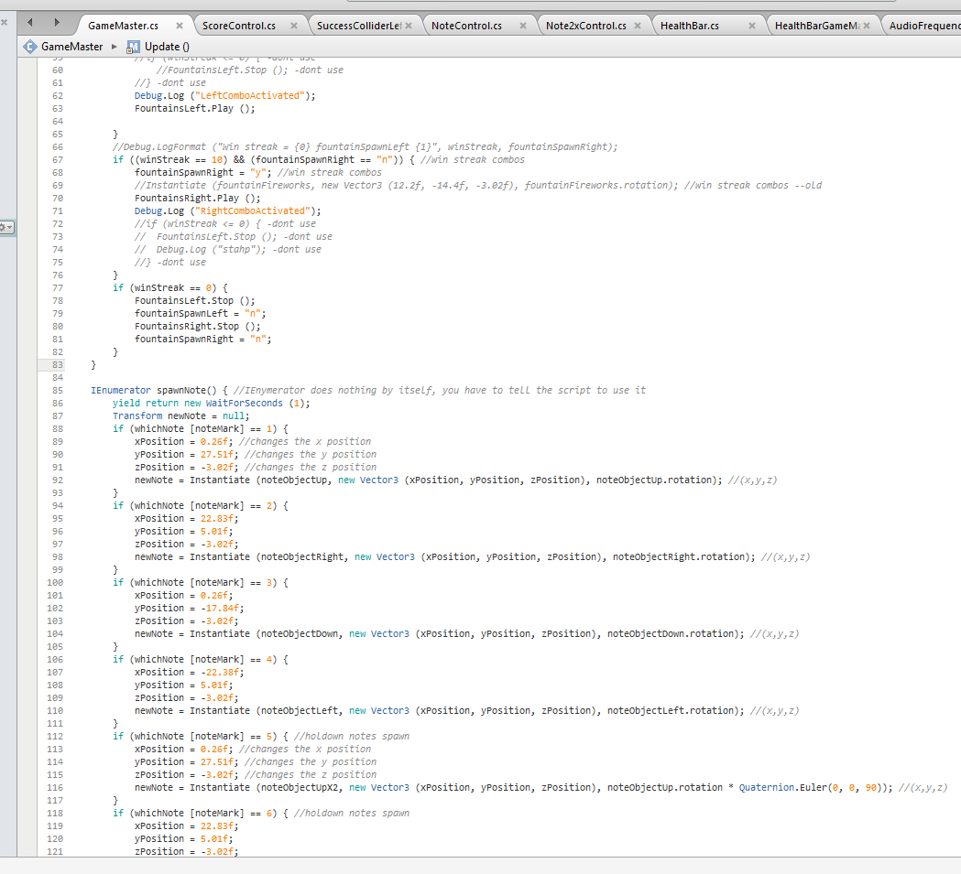

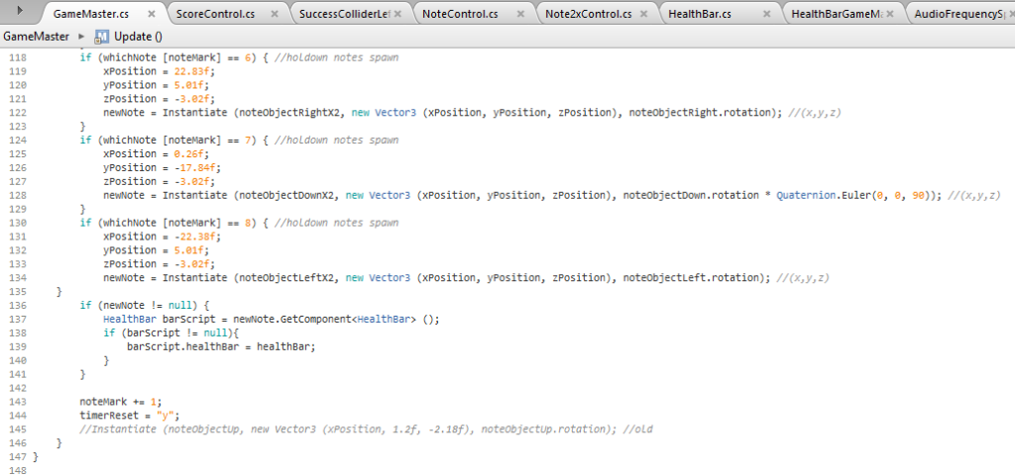

Health Bar:

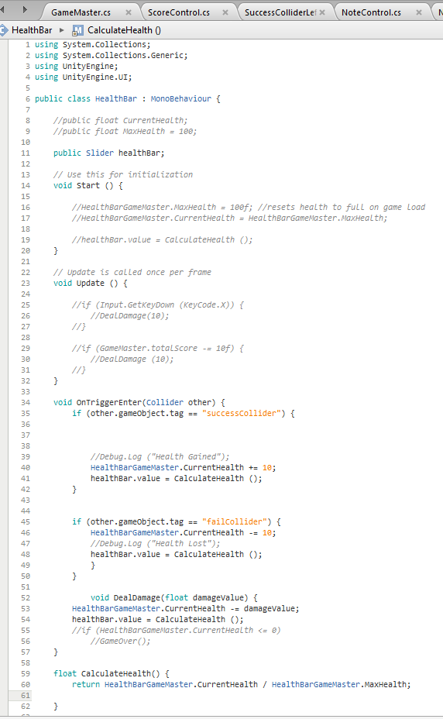

Health bar game master:

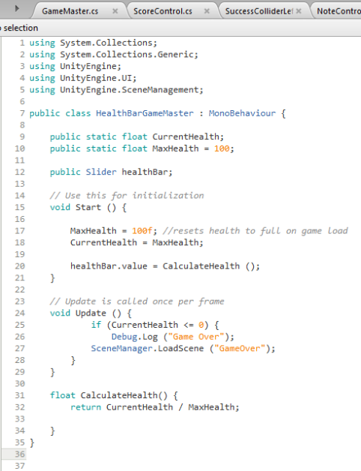

04/12/2018

Paul and I were working on why my pause menu didn’t pause the game properly and required multiple button presses. We found that although I set a pause value in the else section of the if statement linked to the escape button, I hadn’t set a pause value for the resume button which led to the resume button not unpausing properly.

I created a main menu script which handled most of the buttons which changed the scene in my game project.

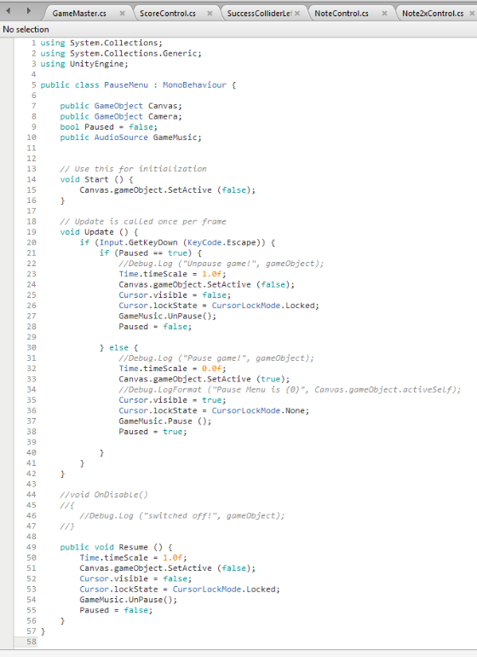

Main menu:

